**Constituency-based parsing trees**

1. **The government raised interest rates.**

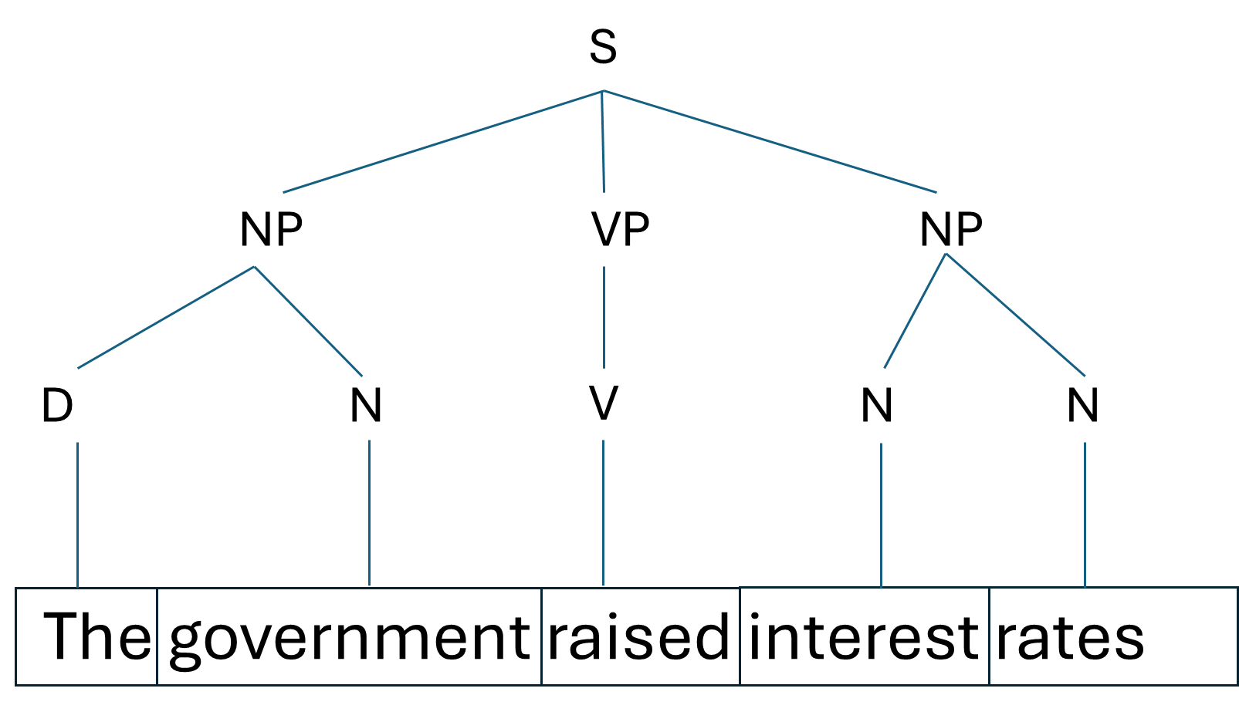

* S represents the entire sentence.
* The sentence is divided into three main parts: NP (Noun Phrase), VP (Verb Phrase), and NP (Noun Phrase).
* The first NP "The government" consists of a determiner (D) "The" and the noun "government".
* The VP "raised" is the main verb of the sentence.
* The second NP "interest rates" is treated as a compound noun, consisting of two nouns (N).

1. **The internet gives everyone a voice.**

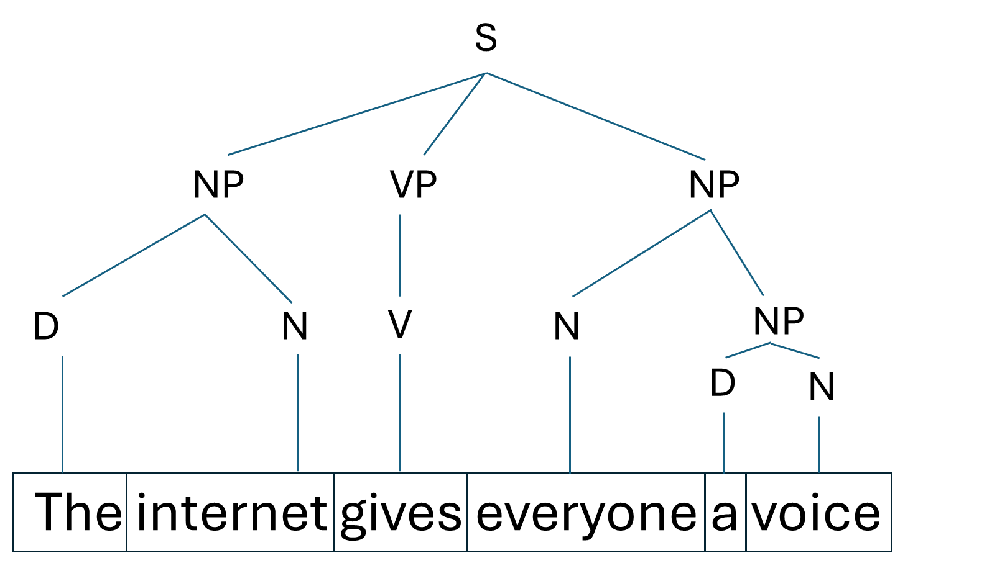

* The sentence is divided into NP, VP, and NP.
* The first NP "The internet" consists of a determiner (D) and a noun.
* The VP "gives" is the main verb.
* The second NP consisting of two parts:
  + "everyone" is treated as a noun (N)
  + "a voice" is a smaller NP within the larger one, with "a" as a determiner (D) and "voice" as a noun (N).

1. **The man saw the dog with the telescope.**

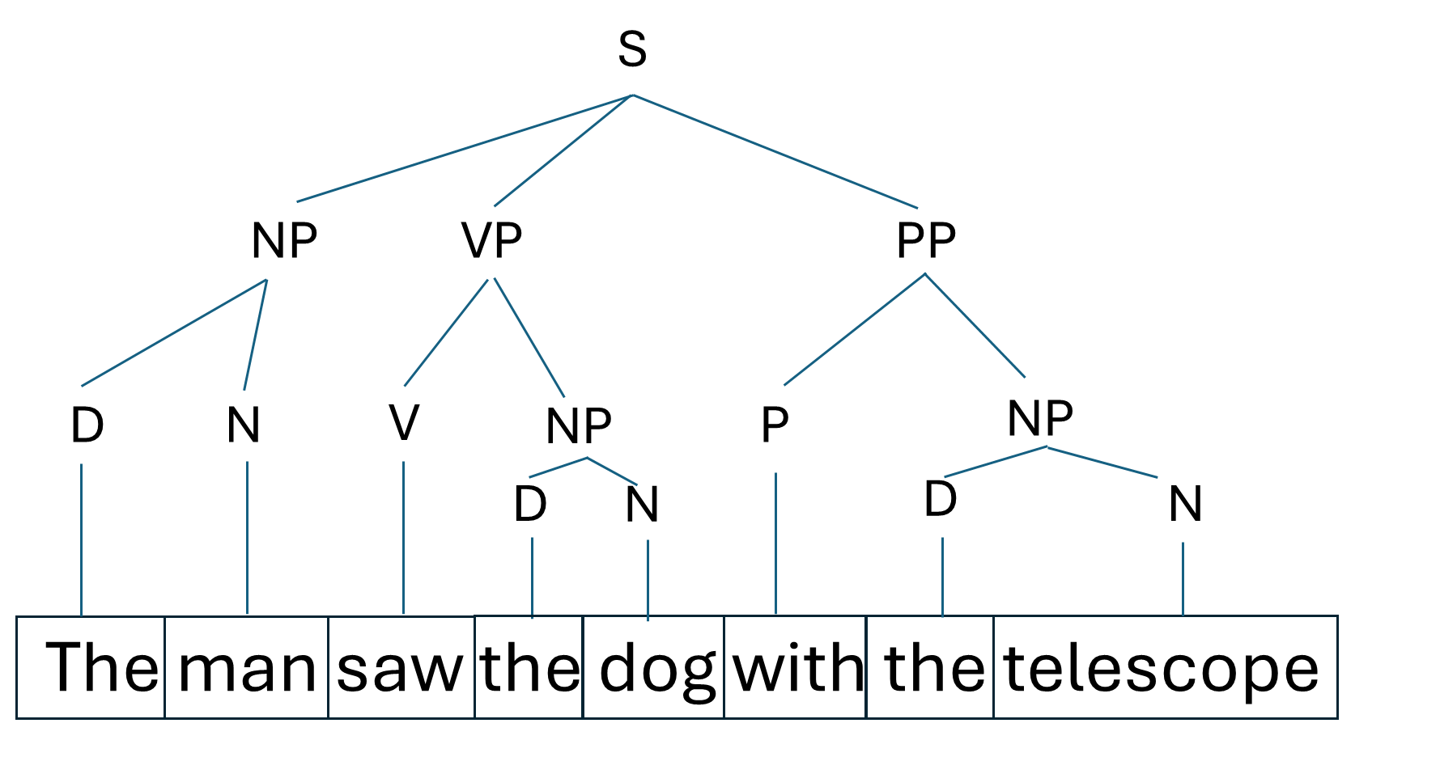

* The sentence is divided into NP, VP, and PP (Prepositional Phrase).
* The first NP "The man" consists of a determiner and a noun.
* The VP "saw" is the main verb, followed by another NP "the dog".
* The PP "with the telescope" is attached to the VP, indicating that the man used the telescope to see the dog.
* Within the PP, "with" is the preposition (P), followed by another NP "the telescope".

Note: This parsing assumes "with the telescope" modifies the verb "saw". An alternative interpretation could attach "with the telescope" to "the dog", which would result in a different tree structure.